Levels of Testing:
- What is UNIT TESTING?
It is also called as module testing /component testing.
It is done to check whether the individual unit or module of the source code is working properly.
It is done by the developer.

- INTEGRATION TESTING?
It is a process of testing the interface between the two s/w units.
It is done by 3 ways:- big-bang , top-down, bottom-up approach.
Process of combining & testing multiple components together.
Normally done by developer but a tester can also perform if he has the knowledge of coding.

- SYSTEM TESTING?
It is a black box testing technique performed to evaluate the computer system.
It include both functional and non-functional testing.
Verifying the completed system to ensure that the application works as intended or not. “The behaviour of the system is tested as defined by the scope of the development project”.
Carried out by specialist tester/independent tester.

- USER-ACCEPATANCE TESTING?
User-requirement testing is done.
Done by client as well as end user.
It is a final stage of testing before used.

- ALPHA-BETA TESTING?
Alpha Developer records all the issues.
o Done by the end user at dev site. (involves client or tester+dev)

Beta→ o Dev go through all the issues after specific period of time.
o Done by the end user at the client site. (involves client/user)

6. What are the different levels of testing?
There are mainly four testing levels and they are:
- Unit Testing
- Integration Testing
- System Testing
- Acceptance Testing
Basically, it starts with the Unit Testing phase and ends with Acceptance Testing.

7. What are the categories of defects?
There are three main categories of defects as shown in the below figure:
- Wrong: It implies that requirements have been implemented incorrectly. It is a variance from the given specification.
- Missing: This is a variance from the specifications, an indication that a specification was not implemented, or a requirement of the customer was not noted properly.
- Extra: It is a requirement incorporated into the product that was not given by the end customer. It is always a variance from the specification but may be an attribute desired by the user of the product.

8. On what basis the acceptance plan is prepared?
Basically, the acceptance document is prepared using the following inputs.
- Requirement document: It specifies what exactly is needed in the project from the customer’s perspective.
- Input from the customer: This can be discussions, informal talks, emails, etc.
- Project plan: The project plan prepared by the project manager also serves as good input to finalize your acceptance test.

9. A defect which could have been removed during the initial stage is removed in a later stage. How does this affect the cost?
If at the initial stage a defect is identified, then it should be removed during that stage/phase itself rather than at some later stage. It’s a fact that if a defect is delayed for later phases it becomes more costly. The following figure shows how a defect is costly as the phases move forward.
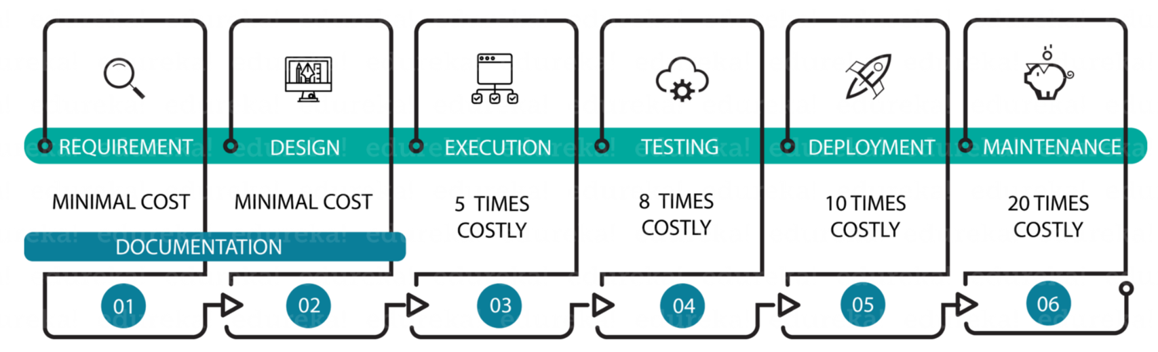If a defect is identified and removed during the design phase, it is the most cost effective but when removed during maintenance it becomes twenty times costlier.

10. On what basis you can arrive at an estimation for your project?
To estimate your project, you have to consider the following points:
- Divide the whole project into the smallest tasks
- Allocate each task to team members
- Estimate the effort required to complete each task
- Validate the estimation

9.

